**DAILY ONLINE ACTIVITIES SUMMARY**

|  |  |  |  |  |  |  |  |
| --- | --- | --- | --- | --- | --- | --- | --- |
| **Date:** | **10-07-2020** | | | | **Name:** | **B.A.SOHANKUMAR** | |
| **Sem & Sec** | **4TH SEM A** | | | | **USN:** | **4AL18CS013** | |
| **Online Test Summary** | | | | | | | |
| **Subject** | | **OBJECT ORIENTED CONCEPT** | | | | | |
| **Max. Marks** | | **30** | | **Score** | | **Not yet declared** | |
| **Certification Course Summary** | | | | | | | |
| **Course** | **SPARK BASICS AND STREAMING** | | | | | | |
| **Certificate Provider** | | | **GLA** | **Duration** | | | **7 HOURS** |
| **Coding Challenges** | | | | | | | |
| **Problem Statement:----** | | | | | | | |
| **Status:----** | | | | | | | |
| **Uploaded the report in Github** | | | | **YES** | | | |
| **If yes Repository name** | | | | **https://github.com/sohannaik5648987/DAILY-REPORTS** | | | |
| **Uploaded the report in slack** | | | | **YES** | | | |

**ONLINE TEST DETAILS:**

Today the test was on 1st module of OBJECT ORIENTED CONCEPT.The duration of the test was 45 minutes from 09.30am to 10.15am.The test was like questions were given and we have to write it and upload it into Google classroom.

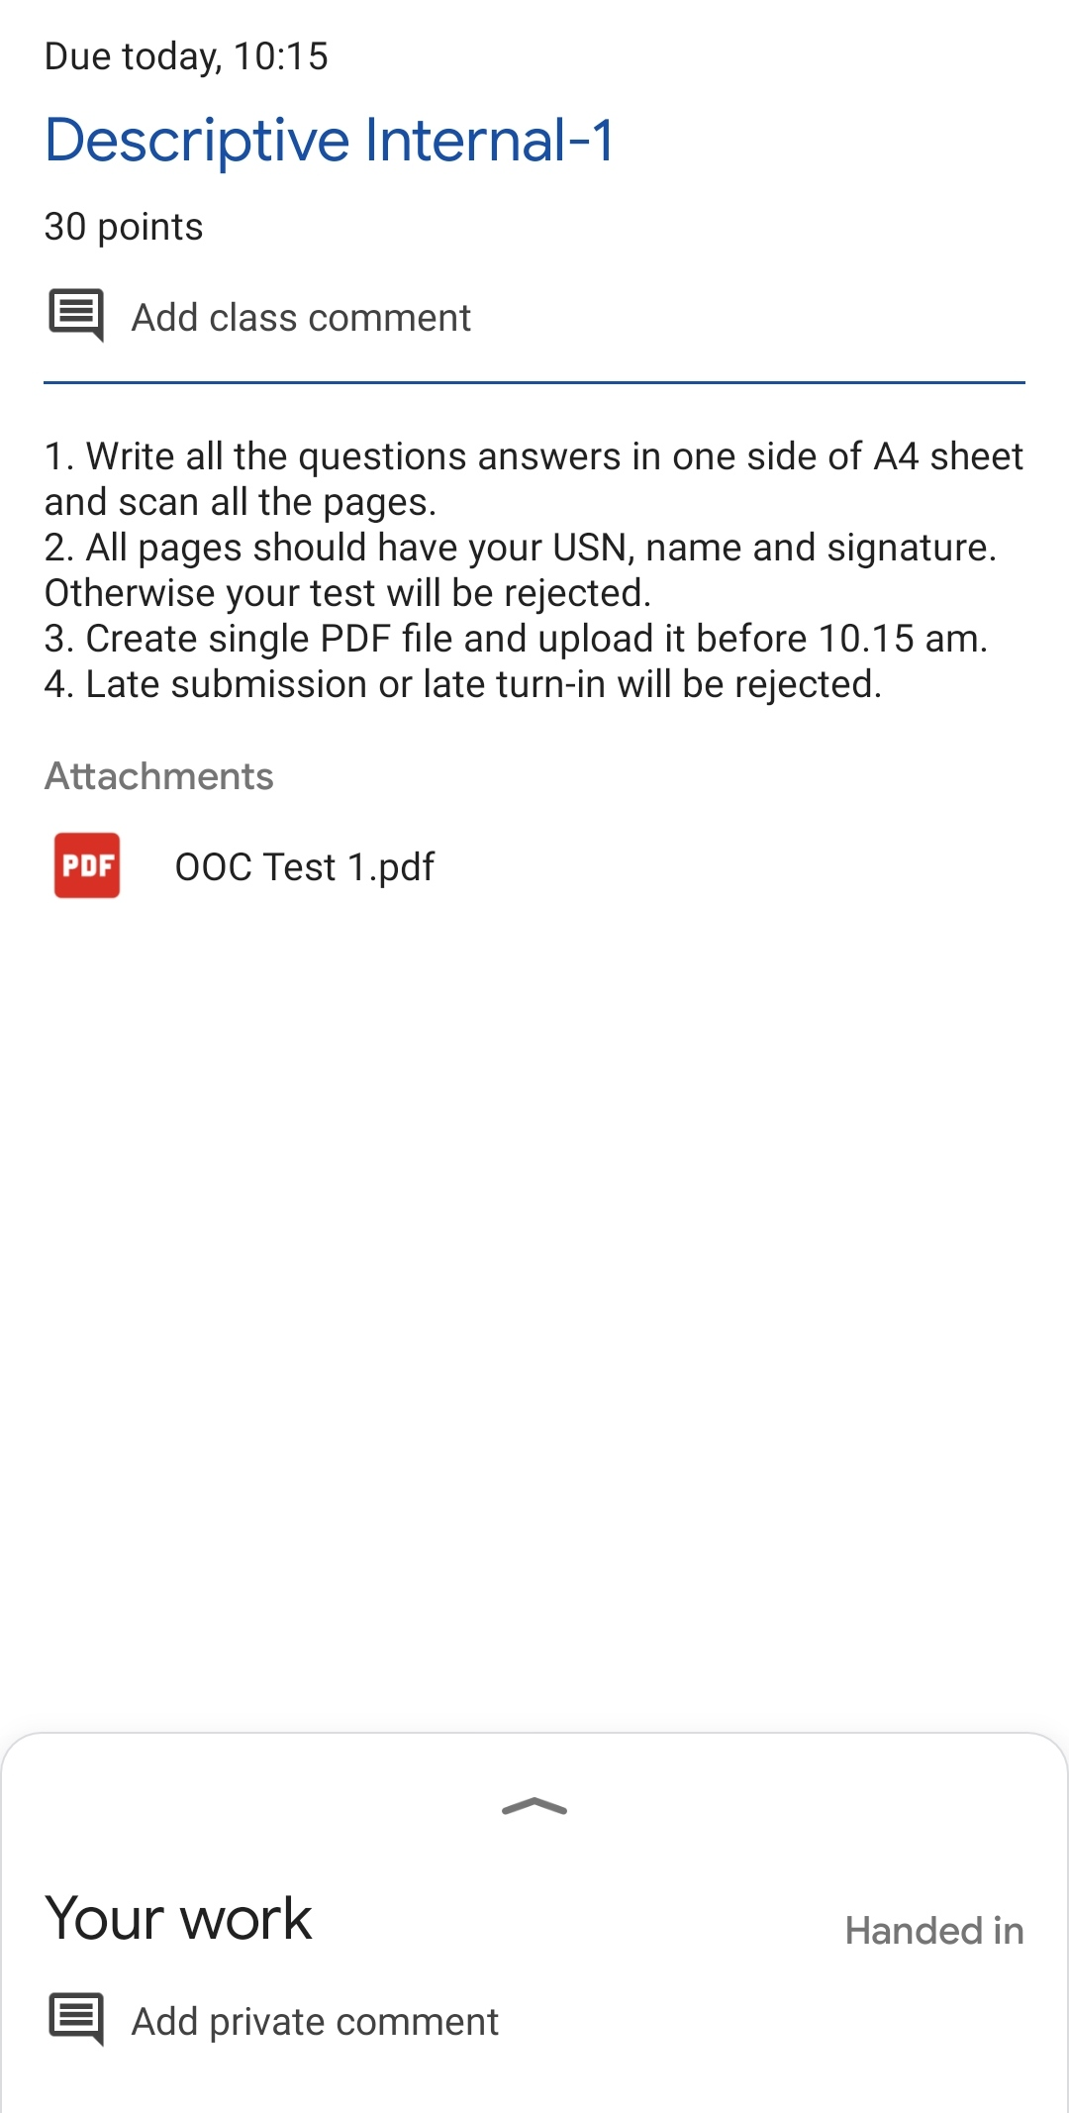

**CERTIFICATION COURSE DETAILS:**

Course:Spark basics and streaming

Completed modules today are Real-time Data Analysis on Twitter Data : Demo,hashtagTrends.ipynb,getTweetsStreaming.ipynb,Case study - Ad tech - 01Case study - Ad tech - 02,Spark Streaming Quiz,Reference: Spark OverviewReference: Databricks Start Guide and successfully completed the course.

